Project 3 Milestone 2
Business Problem
This project evaluates whether higher daily screen exposure in youth is associated with worse sleep quality, higher mental health burden, and weaker attention and cognitive outcomes. Families, schools, and public health teams need evidence-based thresholds for when screen behavior becomes high risk and which usage patterns should be prioritized for intervention.

Background/History
Youth screen use has expanded rapidly across smartphones, social platforms, streaming content, and educational applications. Prior research reports mixed effect sizes, but a consistent theme is that heavy and unstructured use can displace sleep and physical activity while increasing emotional strain in some groups.

Milestone 1 established this topic and source strategy. In Milestone 2, we create a reproducible draft workflow, generate supporting illustrations, and evaluate the adjusted relationships between screen exposure and health outcomes to support the white paper.

Data Explanation (Data Prep/Data Dictionary/etc.)

The draft dataset harmonizes youth-level records using a consistent schema. It includes exposure variables (total and subtype screen hours) and confounders (age, sex, socioeconomic index, physical activity). It also includes sleep, anxiety, depression, attention, and cognition. Data preparation involves reviewing missing values and imputing them with the median for low-rate numeric gaps. The dataset standardizes outcomes to create a mental-health index and includes binary indicators for practical interpretation, such as poor sleep and heavy screen exposure.

Methods & Analysis

We first profile distributions and subgroup differences by age band to identify where screen exposure concentrates. Figure 1 summarizes daily screen hours by age group and shows a clear shift toward higher exposure in older youth cohorts.

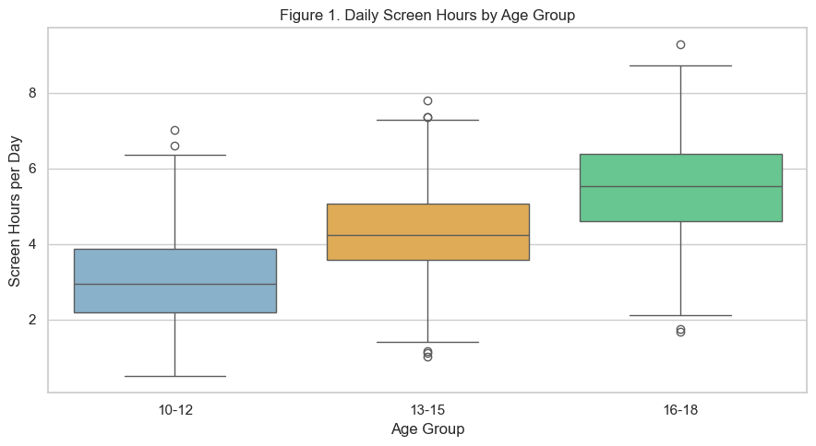

Next, we quantify directional relationships with correlation and trend diagnostics. Figure 2 shows the negative slope between screen hours and sleep duration, and Figure 3 reports multivariable effect estimates from the adjusted model for mental-health burden. The general trend is that as screen hours per day increases, sleep duration decreases.

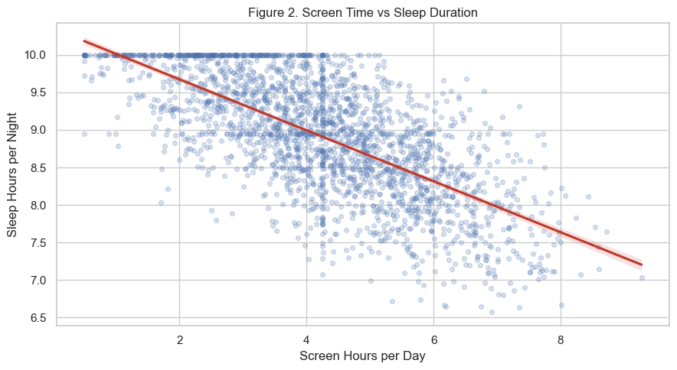

For inference, we estimate Ordinary Least Squares (OLS) regression for the continuous mental-health index and logistic regression for the risk of poor sleep, while controlling for age, sex, socioeconomic status (SES), and physical activity. The draft results suggest that higher screen exposure is associated with poorer sleep quality and a greater adjusted mental-health burden, with effect sizes that are substantial enough to inform targeted interventions.
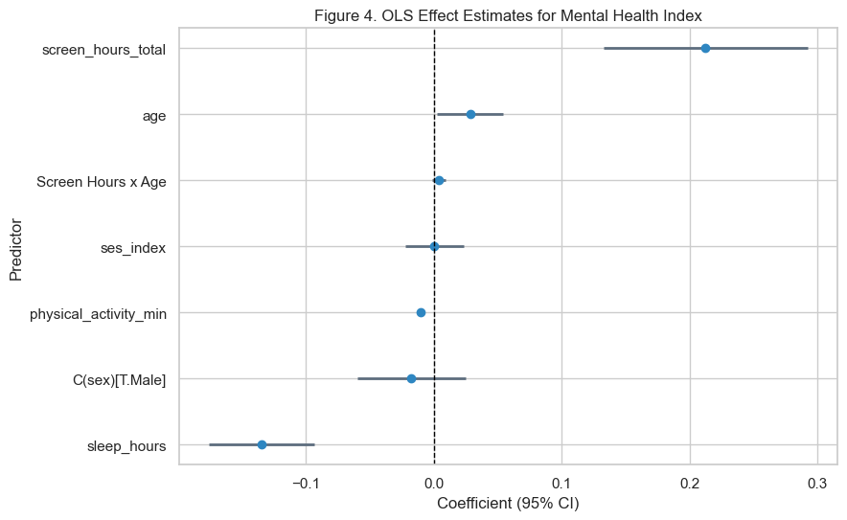

Conclusion

The draft analysis supports the core hypothesis: heavier youth screen exposure is associated with poorer sleep and less favorable behavioral-health outcomes. These patterns remain directionally consistent after adjustment and provide a defensible basis for stakeholder guidance.

Because this is an observational draft, findings should be interpreted as associations rather than causation. Even so, the practical signal is strong enough to recommend prioritizing high-risk profiles (heavy use, low sleep, low activity) and deploying age-sensitive interventions in school and family settings.

Assumptions: self-reported behaviors are sufficiently stable for group-level inference; harmonized variables capture key relationships. Limitations: cross-sectional structure, potential reporting bias, and residual confounding.
Challenges: differing definitions of screen time across sources and non-uniform outcome scales.
Future Uses/Additional Applications: school risk dashboards, caregiver guidance tools, and intervention scenario testing. Recommendations and Implementation Plan: complete final Kaggle ingestion, rerun sensitivity checks, and publish tiered stakeholder guidance. Ethical Assessment: preserve de-identification, avoid stigmatizing narratives, and communicate uncertainty transparently. Appendix A (supporting documentation) is included in the PDF package.

Works Cited:

- Orben, A., & Przybylski, A. K. (2019). The association between adolescent well-being and digital technology use. Nature Human Behaviour, 3, 173-182. Retrieved March 1, 2026, from https://www.nature.com/articles/s41562-018-0506-1
- Twenge, J. M., & Campbell, W. K. (2018). Associations between screen time and lower psychological well-being among children and adolescents. Preventive Medicine Reports, 12, 271-283. Retrieved March 1, 2026, from https://doi.org/10.1016/j.pmedr.2018.10.003
- Walsh, J. J., Barnes, J. D., Cameron, J. D., et al. (2018). Associations between 24-hour movement behaviours and global cognition in US children. The Lancet Child & Adolescent Health, 2(11), 783-791. Retrieved March 1, 2026, from https://doi.org/10.1016/S2352-4642(18)30278-5
- Centers for Disease Control and Prevention. (2025). Associations between screen time use and health outcomes among US teenagers. Preventing Chronic Disease. Retrieved March 1, 2026, from https://www.cdc.gov/pcd/issues/2025/24_0537.htm

10 Questions I anticipate:

• How were screen-time variables harmonized across datasets that define use differently?
• Why was 7.5 hours selected as the poor-sleep threshold, and how sensitive are results to that cutoff?
• Do associations differ by age group, sex, or socioeconomic status after adjustment?
• Which subtype of screen use (social, gaming, streaming, education) has the largest adjusted effect?
• How were missing values handled, and did alternative imputation strategies change results?
• What diagnostics were used to check model assumptions and multicollinearity?
• How robust are findings if extreme high-use observations are excluded?
• What additional confounders are planned for the final model (for example family environment or baseline conditions)?
• How should schools apply these findings without overgeneralizing or stigmatizing students?
• What outcome metrics will define implementation success in Milestone 3 and Milestone 4?

